Structure and union
_________________________________________________________________________________
Q. what is structure?
Structure is a collection of different types of data or it is combination of different kind of data.
If we use array then we can store similar type of data in it but if we want to store different kind of data in it then we can use structure.

Steps to work with structure
___________________________________________________________________
1. Declare structure
______________________________________________________________
If we want to declare structure we have to use struct keyword
Syntax of structure declaration is
struct structname
{ datatype variablename;
datatype variablename;
};
Example:
struct Employee{
int id;
char name[90];
long int sal;
};
If we think about structure it contain three types of data id is type of integer ,name is type of stirng and salary is type of long int
so we can say structure is collection of different types of data.

2. Create Variable of structure or allocate memory of structure
__________________________________________________________________________
If we declare structure then we can see the structure member but we cannot allocate memory of structure means your structure not stored in memory so if we want to allocate memory for structure then we need to declare its variable.

How to declare variable of structure?
______________________________________________________________________________
If we want to declare variable of structure then we have to use following syntax.

Syntax: struct structurename variablename;
Example: struct Employee emp;

if we think about above statement we have structure variable name as emp means we have block in memory whose name is emp and it contain three types of variable shown in following diagram.
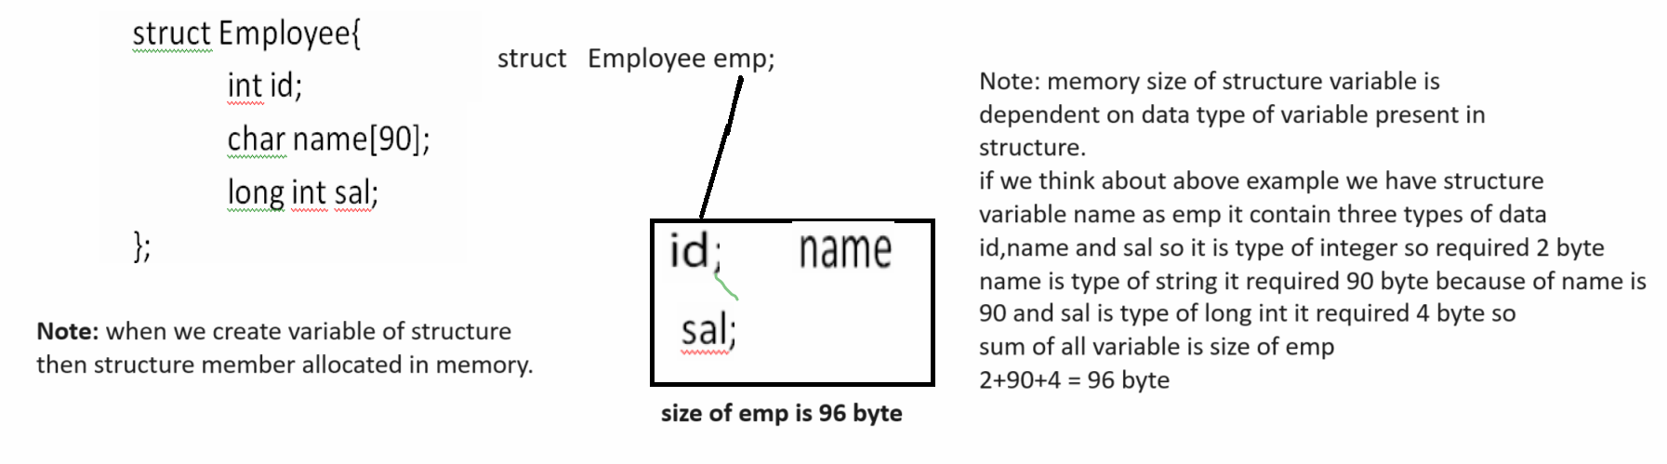
3. Access structure member using variable for store data or retrieve data
________________________________________________________________________________
If we want to access structure variable then we can use structurevariable.member of structure.
Syntax:
structurevariable.membername;
Example:
emp.id=1;
emp.name=”Ram”;
emp.sal=10000;
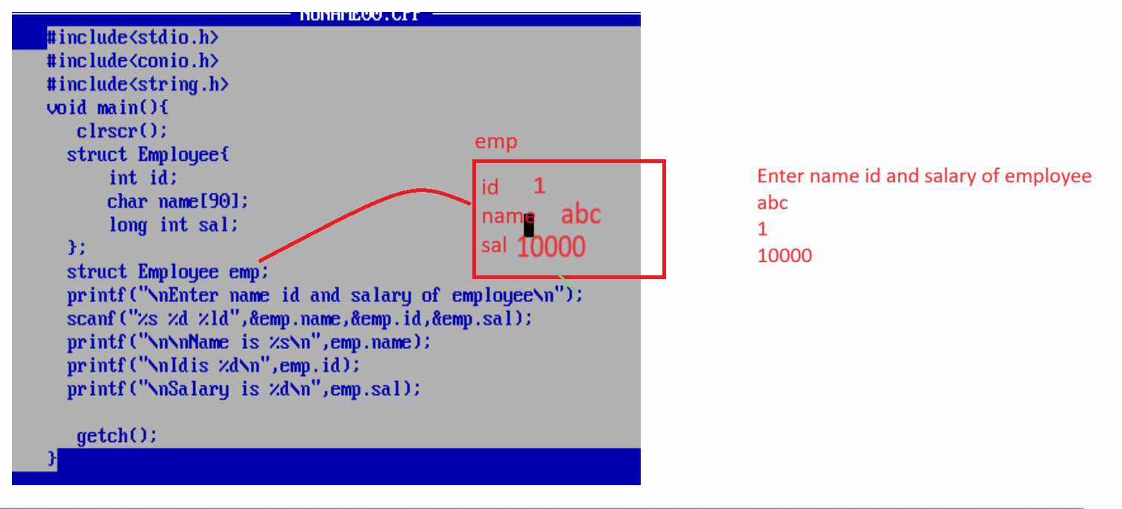

Example: WAP to create structure name as Player with field id, name and run and input the player
detail and display it.

Array of structure
_________________________________________________________________________________
Array of structure is used for store the multiple structure data in single structure variable
Example: we have structure name as Employee with field id, name and sal and we want to input record of 5 employee and display it.
Syntax: struct structurename variablename[size];

Example with source code
#include<stdio.h>
#include<conio.h>
struct Employee{
int id;
char name[90];
int sal;
};
struct Employee emp[5];
void main(){

clrscr();
for(int i=0;i<5;i++)
{ printf("\nEnter name id and salary of employee\n");
scanf("%s %d %d",&emp[i].name,&emp[i].id,&emp[i].sal);
}
printf("\nDisplay all employee data\n");
for(i=0;i<5;i++)
{
printf("%s\t%d\t%d\n",emp[i].name,emp[i].id,emp[i].sal);
}
getch();
}

Example: WAP to create structure name as Book with field id,name and price and create array of structure of 5 and input the id of book and search book present in structure array or not if book present in structure array then show the message book is present otherwise show the message book not present.

Pointer of structure
______________________________________________________________________

Pointer of structure is used for allocate dynamic of structure variable at program run time.
When we use pointer of structure then we can use -> arrow operator for access structure member
(-> tends to) or it is pointer member access operator.
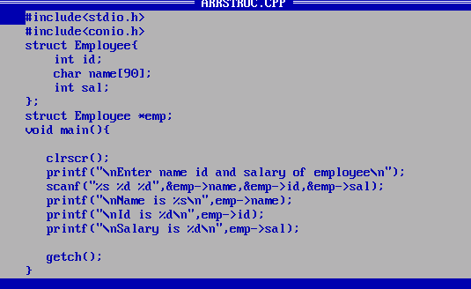

Example: WAP to structure name as Product with field id, name and price and create array of structure of 10 and perform following operation on it.

Case 1: Store data in structure array
Case 2: View all data from structure array
Case 3: arrange all products in descending order by price
Case 4: Delete product by its id and shift index lower side.
Case 5: Search product by name or by id
Case 6: Find the same price product and display it

